5. Plot of Small Circles in Various Projections

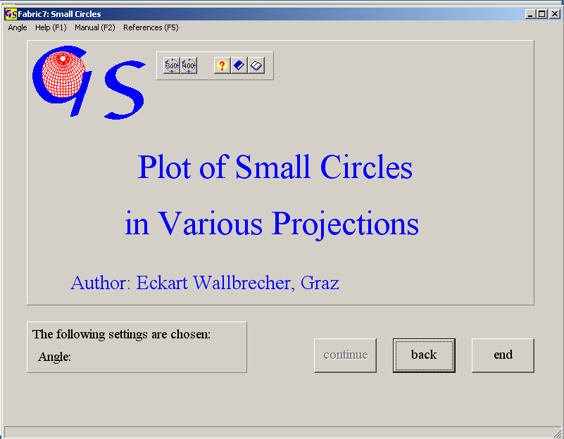
Fig.. 1

This programm (Fig. 1) calculates and plots small circles with the projec-tions which are also used in the other programs. Data input is only manually. Input data are azimuth and angle of dip and the apical angle of the circle (Fig 2). The graphic form is shown in Fig. 3.
All menus are described in program 3.

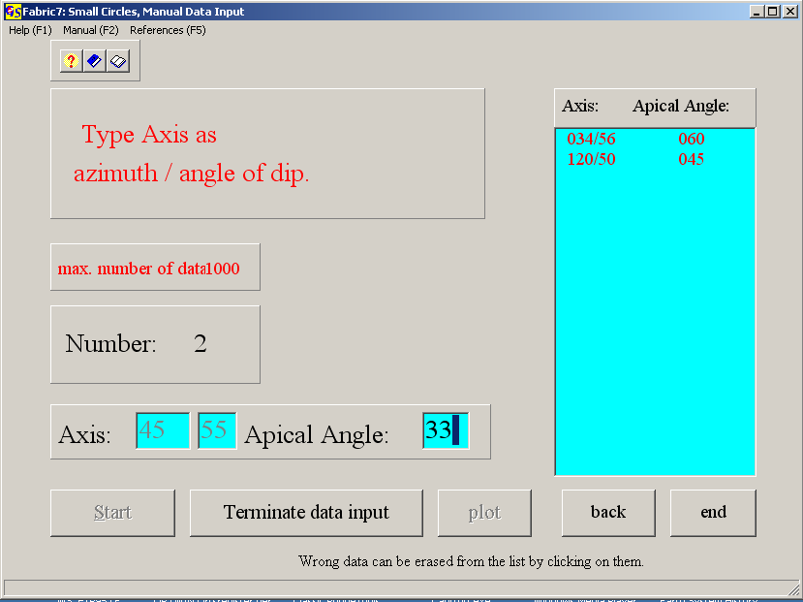 Fig. 2
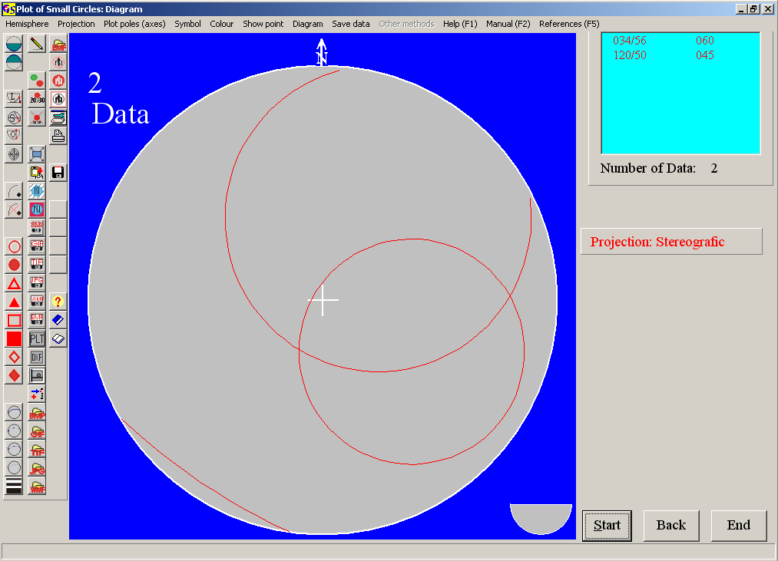
Fig. 3

